CINCINNATUS CENTRAL SCHOOL
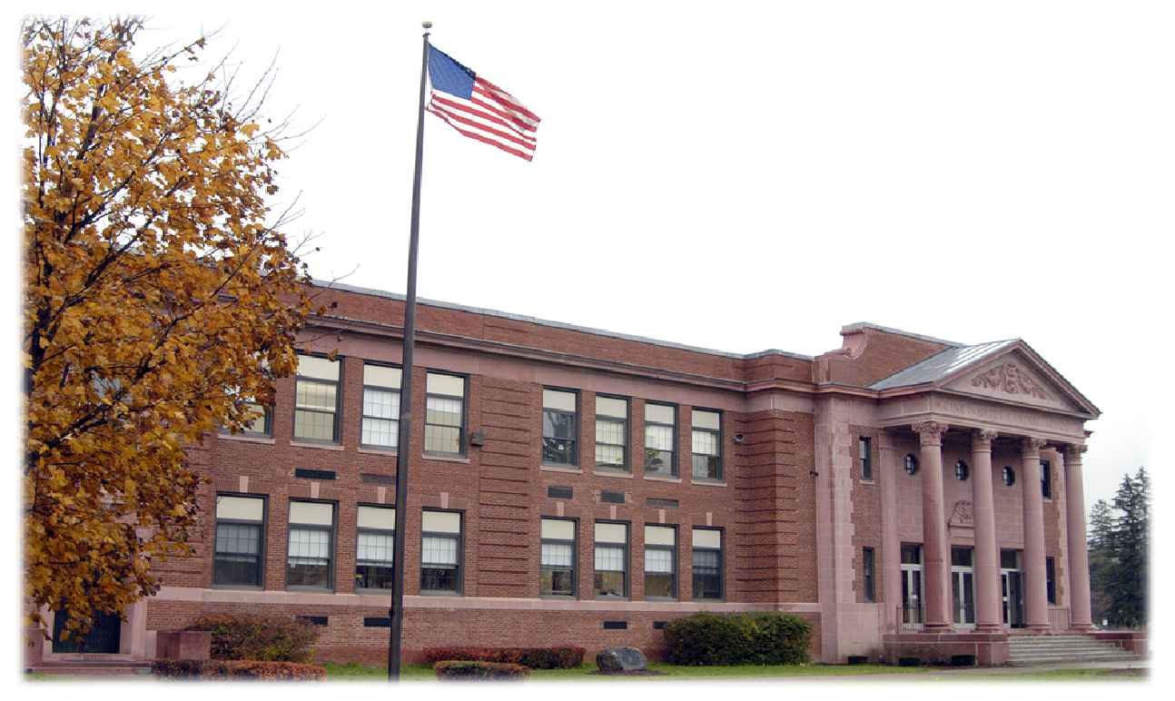

Course Description Handbook

2023-2024

Cincinnatus High School
2809 Cincinnatus Road
Cincinnatus, NY 13040

(607) 863-3200
Fax: (607) 863-3926
TABLE OF CONTENTS

School Counseling Services 3

Course Selection 3

Special Programs 4

Standardized Tests 4

Graduation Requirements 5

Diploma Types 5

Special Endorsements 6

Class Rank – G.P.A. 6

Promotion Guidelines 6

Course Offerings
English Language Arts 7
Social Studies 10
Mathematics 15
Science 19
Languages Other Than English 21
Art 23
Music 28
Computers and Technology 29
Agriculture 32
Health 34
Physical Education 34
Workforce Preparation 35

PURPOSE

This handbook describes the courses offered by Cincinnatus High School. Please read each description carefully before you begin your high school program. Ask questions of your counselor or teachers if you want additional information about specific courses and how they may fit into your career plans. As you make decisions regarding your program, you should discuss your choices with your counselor and your parents/guardians. Together, you can plan a program that meets both your immediate and long-term goals.

SCHOOL COUNSELING SERVICES

The School Counseling Department at Cincinnatus Central School provides students and parents with a wide variety of services, including:

- Academic program planning
- Career counseling
- College advisement and financial planning
- Standardized testing navigation
- Personal counseling
- Referral to helping agencies
- Crisis Intervention
- Consultation

COURSE SELECTION

As you begin to select courses, there are many factors to consider. Course selection is related to your goals, learning needs and your post secondary plans. What courses will help you learn in the best way for you as well as help you reach your goals and provide an opportunity to learn and grow as a student? What are your plans for after you graduate? Will you attend college? Do you plan to attend BOCES and go into the workforce? Does a gap year sound interesting? Maybe you have plans to enter the military. Will you do so after some college or before college? Do you know what type of focus you will have once in the military?

Naviance is a tool we will use with you to explore your interests and assist you in your career goals. Through the career exploration you will hopefully find an area of interest and choose courses that help you expand on your career interests. Attending a vocational program at BOCES may be what you are interested in pursuing as a junior. Consideration of BOCES programs begins in ninth and tenth grade to ensure you select the right courses.

Your counselor will use your transcript to determine the courses you still need to take for graduation. This is the official record of your courses, grades and tests results for all high school courses. This document is used each year to plan next year’s course selection.

This is also an important time to share your thoughts with the adults in your life. Please make sure to review your course selections with your parents/guardians.

SPECIAL AND ADVANCED PROGRAMS

In addition to the regularly scheduled offerings, the following programs are available.

Honors Course Requirements

Science Department:
During the previous years science course, the following criteria must be met and observed:

Living Environment Honors
- Minimum of an 85% average in the previous honors course for marking periods 1-3 (either Honors Earth or Honors 8)
- Interest from the student
- Consistent work completion and use of feedback to improve work
- Consistent appropriate group interactions during laboratory experiences
- Teacher recommendation from previous science course

College Courses
Twelfth grade students have opportunities at both the State University of New York at Cortland and Tompkins-Cortland Community College to take college-level courses on a college campus while still in high school. The decision to leave the Cincinnatus School campus to attend one of the above colleges is a decision made in conjunction with parents/guardians. All financial obligations as well as transportation needs will be provided by the family, not CCS. Students enrolling in courses of this type typically spend part of their day at Cincy and then travel to the college campus. Grades will be provided through the college at the end of each semester and it is the responsibility of the student to provide Cincinnatus CS with a copy of each grade report received. It is important to plan this process carefully to make sure you will have all of the requirements necessary to fulfill any graduation requirements before graduation.

Concurrent Enrollment Courses
Concurrent Enrollment Courses are college courses taught at Cincinnatus High School by our teachers and students earn college and high school credit by completing each course. At present, Cincinnatus offers the following concurrent enrollment courses: College Writing, College Literature, College Algebra and Trigonometry, Pre-Calculus, Calculus I and II, Advanced Art 1, Photojournalism, Physics, World History I and II, and American National Government. No fee is involved, but students must show residency in Cortland County or complete the necessary forms if a resident of another county. It is important to plan this process carefully to make sure you will have all of the requirements necessary to fulfill any graduation requirements before graduation. Grades will be reported on a high school transcript as well as a college transcript. Students are responsible for requesting the college transcripts for any credit transfer opportunities with future colleges.

Academic Intervention Services (AIS)
Academic Intervention Services are provided to assist students in successfully meeting the New York State learning standards and graduation requirements. Students qualify for AIS by scoring below a designated level on the New York State Intermediate (Grade 8) assessments in English Language Arts, Mathematics, Social Studies, and Science or on any of the Regents exams needed for graduation. Additional instruction and support is provided in these subjects, during the school day.

STANDARDIZED TESTS

We recommend that all students take the Preliminary Scholastic Aptitude Test (PSAT) in the fall of their sophomore or junior year. As juniors, the PSAT is the qualifying exam for the National Merit Scholarship Program. There are two other college entrance exams to consider: Scholastic Aptitude Test (SAT) and/or the American College Test (ACT). These are offered throughout the calendar year and require students to register in advance on the computer. Students are encouraged to see their school counselor to determine which test is most appropriate or if you have questions or concerns.

GRADUATION REQUIREMENTS

In order to earn a high school diploma, students must earn a minimum of 22 units of credit, in the following manner:

English 4 credits
Social Studies 4 credits
Mathematics 3 credits
Science 3 credits
Health 0.5 credit
Art or Music 1 credit
LOTE (Languages Other Than English) 1 credit
Physical Education 2 credits
Electives 3.5 credits

Cincinnatus Central School requires all students to take and pass any Technology or Agriculture course. The credit for this course is included in the credits for electives.

Two of the three required units of credit in Science must reflect the following:
(1) at least one unit of credit in life science (aligned to the State’s living environment standards);
(2) at least one unit of credit in physical science (aligned to the State’s physical setting standards).

In addition, students opting for a Regents diploma with advanced designation must earn EITHER three units of credit in one language other than English OR five units of credit in art, music, or career and technical education (workforce prep courses or computer technology courses).

TYPES OF DIPLOMAS

Regents Diploma with Advanced Designation:
Students must score 65 or above on 8 Regents exams and earn 22 units of credit.
Students are required to take and pass the following: Two Regents exams in Science, three Regents exams in Math,
the Global Studies Regents exam (grade 10), the US History & Government Regents exam (grade 11), and the Comprehensive English Regents exam (grade 11).

Regents Diploma:
Students must score 65 or above on 5 Regents exams and earn 22 units of credit.
Students are required to take and pass: one Regents exam in Science, Math, Global Studies (grade 10), US History
& Government (grade 11), Comprehensive English (grade 11).

Local Diploma (Special Education students only):
Students must score 55-64 on 5 Regents exams and earn 22 units of credit.

Other Requirements:

Students in grades 9-11 are expected to take SIX subjects each year in addition to Physical Education
Seniors must take FIVE subjects each year in addition to Physical Education.

Exiting Credential Requirements (Special Education students only):
Career Development and Occupational Studies: Students with disabilities are able to earn a New York State (NYS) Career Development and Occupational Studies (CDOS) Commencement Credential. This credential recognizes each individual student’s preparation and skills for employment. Where in the past, many students graduated with an individualized education program (IEP) diploma, this credential provides a more meaningful substitute for these students. For students with disabilities who are exiting with a regular high school diploma, it provides them with the additional opportunity to exit school with a credential that also recognizes the students’ work readiness skills.

Skills and Achievement Commencement Credential: For those students with disabilities who are eligible to participate in the New York State Alternative Assessments, the Skills and Achievement Commencement Credential (SACC) provides students with a commencement certificate similar in form to the diploma issued by the school district. The Skills and Achievement Commencement Credential must be accompanied by documentation of the student’s skills and strengths and levels of independence in academic, career development and foundation skills needed for post-school living, learning and working.

Special Endorsements
Honors: A student earns a compute average of at least 90 on the Regents Exams applicable to either a Regent diploma or a Regents diploma with advanced designation. No more than 2 Department approved alternatives can be substituted for Regents Exams. The locally developed Checkpoint B exam in World Languages in NOT included in the calculation.

Mastery in Math and/or Science: A student meets all requirements for a Regents diploma with advanced designation AND earns a score of 85 or better on 3 math Regents Exams and /or 3 science Regents Exams.

Technical Endorsement: A student meets the requirements for either a local diploma, a Regents diploma or a Regents diploma with advanced designation AND successfully completes a Department approved CTE program including the 3 part technical assessment.

Seal of Biliteracy: A student meets the criteria for earning the NYS Seal of Biliteracy through their work in French or Spanish.

CLASS RANK – G.P.A.

Students receive a weighted average their senior year to determine class rank and G.P.A. (grade point average) for college and scholarship applications. Final class rank is determined after the 2nd marking period of their senior year (seven semesters).

Courses are weighted as follows:
1.10 Advanced Placement courses, College Level Courses (College Writing, College Literature, Pre-Calculus, Calculus, Calculus II, College Algebra, Physics, French IV, Spanish IV).
1.05 Honors classes
1.00 All other courses

PROMOTION GUIDELINES

To be considered a 10th grader, a student needs to have passed English 9 or Global History and Geography I and earned a minimum of 4 ½ credits.

To be considered an 11th grader, a student needs to have passed English 10 or Global History and Geography II and earned a minimum of 9 ½ credits.

To be considered a 12th grader, a student needs to have passed English 11 or United States History and Government and earned a minimum of 15 credits.

Students may need to take any failed courses again, either during the summer or during the next academic year.

COURSE OFFERINGS

ENGLISH LANGUAGE ARTS

Contemporary Classics
Grade level: 9/10
Number of weeks: 20
Prerequisite: English 8
Units of credit: 1/2

This half year course will focus on some of the most famous works of literature in the English Language. The course will feature many of the major works of literature that most high school students read before graduating from high school. Titles may include To Kill a Mockingbird, Night, Animal Farm, The Old Man and the Sea, and Lord of the Flies.

Reading and Writing in Sports Literature
Grade level: 9/10
Number of weeks: 20
Prerequisite: English 8
Units of credit: 1/2

This half year course will survey major authors and styles in sports literature. This course will try to answer the following questions: What role do sports play in our society? What role do sports have in our individual lives? What is the definition of sport? How has the concept of sport changed through the years? Is there a national sport in the United States? Do sports unify us or divide us? How and why have athletes chosen to use sports as a platform for societal change? Units focus on: Endurance and Strength, Fandom, and Sports in Society and Culture.

Suspense, Horror, and Gothic Literature:
Grade level: 9/10
Number of weeks: 20
Prerequisite: English 8
Units of credit: 1/2

This half year course will survey major authors and styles in the genre of suspense, horror, and gothic literature. This course will try to answer the following questions: How do we define suspense, horror, and gothic literature? What is the allure of fear? How does imagination overcome reason? When does uncertainty develop into fear? What is transformation, and why is it frightening? Titles may include Bird Box, Carrie, Blood Meridian.

Realistic Fiction
Grade level: 9/10
Number of weeks: 20
Prerequisite: English 8
Units of credit: 1/2

This half year course will focus around fiction that depicts our world and society. We will concentrate on themes like growing up and confronting personal and social problems.

Poetry
Grade level: 9-12
Number of weeks: 20
Prerequisite: English 8
Units of credit: 1/2

This half year course will take a thorough dive into reading, interpreting, and writing poetry. The course will focus on a wide selection of poets and books written in verse.

Dystopian Literature
Grade level: 9/10
Number of weeks: 20
Prerequisite: English 8
Units of credit: 1/2

This half year course will survey authors and styles related to the popular genre. Throughout this course we will read to analyze the imaginary worlds that provide commentary on the current trends, political systems, or popular culture of modern times.

Literature of Conflict
Grade level: 9/10
Number of weeks: 20
Prerequisite: English 8
Units of credit: 1/2

This half year course will survey authors and styles related to various world conflicts and wars. Throughout this course we will read articles, short stories, poems, and novels about both war and peace from a variety of perspectives. We will reflect on the nature of conflict itself, the ongoing conflict between war and peace, and the effects of conflicts on those involved.

Mythology
Grade level: 9/10
Number of weeks: 20
Prerequisite: English 8
Units of credit: 1/2

This half year course will survey myths and legends from around the world. We will analyze and discuss the origins and functions of mythology in various cultures.

English 11
Grade level: 11
Number of weeks: 40
Prerequisite: English 10
Number of credits: 1

Eleventh grade English focuses on the study of American literature. Students will examine various genres of literature, including short stories, novels, poetry, and other forms of media. Various activities will be performed throughout the year to help students understand the period in which the literature was written.
A substantial portion of English 11 will focus on intensive Regents Exam preparation, including actual tasks from previous exams, as well as parallel assessment tasks (tasks similar to those on the Regents exam). Students will write essays for understanding, comprehension, analysis, and interpretation.

English 12
Grade level: 12
Number of weeks: 40
Prerequisite: English 11
Number of credits: 1

This course focuses primarily on British Literature and prepares students for life beyond high school. Students study British and some American literature ranging from the Anglo-Saxon period to contemporary works. To continue developing an appreciation for literature, students also read and analyze self-selected works. In studying literature, literary elements and thematic classifications are examined and applied. Students will prepare two research papers; one on the topic of college/career choice, the other on a major British author (or his/her work). Attention will be given to researching colleges and careers, practicing college applications and essays, and writing cover letters and resumes. Students will be engaged in real-life activities that focus on research, self-analysis, and writing.

College Writing (ENGL 101) (Concurrent Enrollment)
Grade level: 12
Number of weeks: 20
Prerequisite: A score of 85 or better on the Comprehensive English Regents Exam.
Number of credits: ½ HS – 3 credits from TC3

Students in this course will develop and refine an effective writing process which will include: planning, invention, drafting and revision. They will develop critical thinking skills necessary for researching and writing on a topic, as well as analyzing and utilizing readings from a variety of disciplines. Students develop information literacy skills as they engage in the research process. Grammar skills and the use of proper documentation will be emphasized as well. College credit will be earned through TC3 with a grade of C or better. The college you attend will have the final decision about what credits they accept.

College Literature (ENGL102) (Concurrent Enrollment)
Grade level: 12
Number of weeks: 20
Prerequisite: Successful completion English 101 College Writing with a B or better (transferable credit)
Number of credits: ½ HS – 3 credits from TC3

Students in this course will be introduced to major aspects of literature. They will develop an understanding and an appreciation as they analyze and write about various forms of literature which include: drama, fiction, and poetry. College credit will be earned through TC3 with a grade of C or better. The college you attend will have the final decision about what credits they accept.

SOCIAL STUDIES

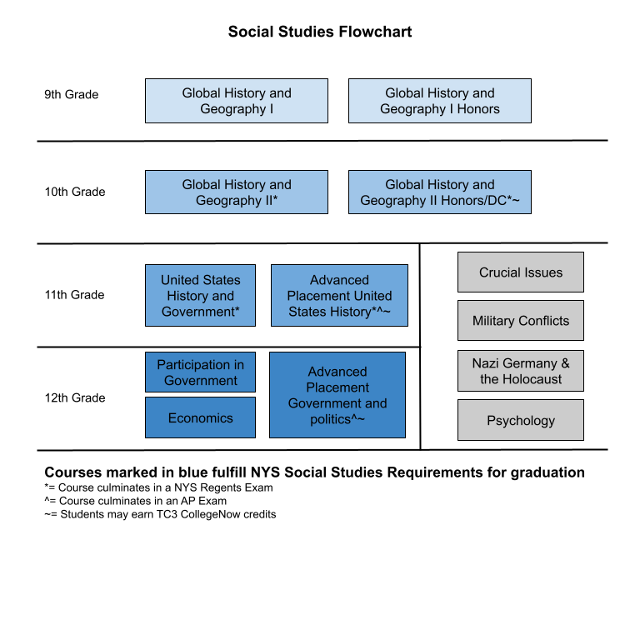

Global History and Geography I
Grade Level: 9
Number of Weeks: 40
Prerequisite: 8th grade US History
Number of Credits: 1

Grade 9 begins with the Paleolithic Era and the development of the first civilizations, continues with an examination of classical societies, and traces the expansion of trade networks and their global impact. The course emphasizes the key themes of interactions over time, shifts in political power, and the role of belief systems. While the course emphasizes the importance of historical and spatial thinking, all of the social studies practices and standards are included in the study of global history and geography.

Global History and Geography I Honors
Grade Level: 9
Number of Weeks: 40
Prerequisite: 8th grade US History, 85 or higher in the class, and teacher recommendation
Number of Credits: 1

This course is designed as a study of world history and civilizations before 1750 CE. Students will study the political, economic, religious, cultural, social, and intellectual movements and changes that create the modern world (after 1500 CE). The course will focus on ancient to Renaissance periods of history in Asia, Africa, Europe, the Americas, and the Middle East. Course material will be delivered in multiple ways throughout the school year with a special focus on primary sources and historiographical reading. This course is a pre-college course designed to help students develop better historical reading and writing skills necessary to continue on to Global History and Geography II Honors.

Global History and Geography II
Grade Level: 10
Number of Weeks: 40
Prerequisite: Global History and Geography I
Number of Credits: 1

Grade 10 provides a snapshot of the world circa 1750. The course continues chronologically up to the present. Several concepts are woven throughout the course including industrialization, nationalism, imperialism, conflict, technology, and the interconnectedness of the world. While the course emphasizes the importance of historical and spatial thinking, all of the social studies practices and standards are included in the study of global history and geography. At the end of the course, students will take a Regents Exam.

Global History and Geography II Honors (Dual Enrollment)
Grade Level: 10
Number of Weeks: 40
Prerequisite: Global History and Geography I/Honors I, 85 or higher in the class and on the final
exam, and teacher recommendation
Number of Credits: 1 HS - 3 college credits

This class is taught as HSTY 117: The West in World History since 1500, a TC3 College Now class. Students will earn both high school and college credit; which may be transferable to college as the student gets a B or better in the class. If the student gets below a B, the student will get TC3 credit, but it may not be transferable.
This course is designed as a study of world history and civilizations since 1500 CE. Students will study the political, economic, religious, cultural, social, and intellectual movements and changes that create the modern world. The course will focus on the Renaissance to the modern day periods of history in Asia, Australasia, Africa, Europe, the Americas, and the Middle East. Course material will be delivered in multiple ways throughout the school year with a special focus on primary sources and historiographical reading. Students will be taking the Global History and Geography Regents Exam in June. HSTY 117 fulfills the SUNY General Education Other World Civilizations requirement. At the end of the course, students will take a Regents Exam.

United States History and Government
Grade Level: 10
Number of Weeks: 40
Prerequisite: Global History and Geography II
Number of Credits: 1

Grade 11 begins with the colonial and constitutional foundations of the United States and explores the government structure and functions written in the Constitution. The development of the nation and the political, social, and economic factors that led to the challenges our nation faced in the Civil War are addressed. Industrialization, urbanization, and the accompanying problems are examined, along with America’s emergence as a world power, the two world wars of the 20th century, and the Cold War. Students explore the expansion of the federal government, the threat of terrorism, and the place of the United States in an increasingly globalized and interconnected world. At the end of the course, students will take a Regents Exam.

Advanced Placement United States History (Dual Enrollment)
Grade Level: 11
Number of Weeks: 40
Prerequisite: Global History and Geography II/Honors II, 85 or higher in the class and on the Global
History and Geography Regents exam, and teacher recommendation
Number of Credits: 1 HS - 6 college credits
The AP U.S. History course is designed to provide the same level of content and instruction that students would face in a freshman-level college survey class. The course covers 9 periods of US History, spanning from the pre-Columbian era to the present day. Students will assess historical thinking skills aligned with the AP exam - change and continuity over time, causation, comparison and turning point. Students will also learn history through various themes - American and National Identity, Politics and Power, Work, Exchange, and Technology, Culture and Society, Migration and Settlement, Geography and the Environment, and America in the World. At the end of the course, students will take an AP Exam and the United States History and Government Regents exam. Students will also be enrolled in two TC3 College Now courses: HSTY 201: American History to 1877 and HSTY 202: American History from 1877. These credits may be transferable to college as the student gets a B or better in the class. If the student gets below a B, the student will get TC3 credit, but it may not be transferable. Students may be able to transfer credits from the AP course depending on the score earned or the TC3 college credits, but not typically both.
Economics
Grade Level: 12
Number of Weeks: 20
Prerequisite: United States History and Government
Number of Credits: ½

“Economics, the Enterprise System, and Finance” examines the principles of the United States free market economy in a global context. Students will examine their individual responsibility for managing their personal finances. Students will analyze the role of supply and demand in determining the prices individuals and businesses face in the product and factor markets, and the global nature of these markets. Students will study changes to the workforce in the United States, and the role of entrepreneurs in our economy, as well as the effects of globalization. Students will explore the challenges facing the United States free market economy in a global environment and various policy-making opportunities available to government to address these challenges

Participation in Government
Grade Level: 12
Number of Weeks: 20
Prerequisite: United States History and Government
Number of Credits: ½

Participation in Government (PIG) is required for graduation. It is designed to give students a well-rounded knowledge of the connection between democracy and the people. Students will examine the US constitution and the Bill of Rights and other key amendments in great detail. Students will study the interactions among the different branches of government and their respective functions in our system of government. Students will study how linkage institutions, like the media, political parties and interest groups affect government and politics. Students will demonstrate understanding of the role of our state and local governments as well. Students are tasked with a series of projects and or essays on critical social issues that are current in our society. Lastly, students will study the roles of the United States in world affairs.

Advanced Placement Government and Politics (Dual Enrollment)
Grade Level: 12
Number of Weeks: 40
Prerequisite: United States History and Government/AP US History, 85 or higher in the class and on
the Global History and Geography and/or United States History and Government exam,
and teacher recommendation
Number of Credits: 1 HS - 3 college credits
AP U.S. Government and Politics is a college-level year-long course that not only seeks to prepare students for success on the AP Exam in May, but also provides students with the political knowledge and reasoning processes to participate meaningfully and thoughtfully in discussions and debates that are currently shaping American politics and society. It is important to note that this course is not a history course; it is a political science course that studies the interconnectedness of the different parts of the American political system and the behaviors and attitudes that shape this system and are the byproduct of this system.
AP U.S. Government and Politics accomplishes these goals by framing the acquisition of political knowledge around enduring understandings and big ideas about American government and politics that can be applied to a set of disciplinary practices through the use of a set of reasoning processes. Through the development of this set of political knowledge, disciplinary practices, and reasoning processes, by the end of the course, students will be able to analyze current and historical political events like a political scientist and develop factually accurate, well- reasoned, thoughtful arguments and opinions that acknowledge and grapple with alternative political perspectives.
Students are expected to take the AP Exam in May. Credits will be earned through TC3 and may be earned based on the score earned through College Board. Typically, students will choose which credit they will transfer to the college of their choice.
Introduction to Psychology
Grade Level: 11 & 12
Number of Weeks: 20
Prerequisite: Global History and Geography II/US History and Government - must pass Regents
Exams
Number of Credits: ½
This is an introductory level psychology course in which students will have the opportunity to get an overview of the field of psychology. Students will examine the history and development of the field of psychology, as well as the leading figures associated with its development. In addition, students will learn about the Biological Basis of Psychology, Sensation and Perception, Learning and Memory, Personality Development, and Early Childhood Development. Through labs and research, students will experience hands-on learning experiences as they explore the field of psychology.
Crucial Issues
Grade Level: 11 & 12
Number of Weeks: 20
Prerequisite: Global History and Geography II/US History and Government - must pass Regents
exams
Number of Credits: ½

This is an elective course in which we will take a historical and contemporary look at issues throughout the world. This course provides students an opportunity to familiarize themselves with the issues that frequent newspapers, television news, and other popular media and fuel the controversies that both divide our population here in the United States and around the globe. The course will be flexible in nature to accommodate significant current events and engage students through their interests. Discussion and participation are an essential component of the course. Students are required to “teach” their own crucial issue as a culminating project. The general structure for the course, however, will be to identify crucial issues, and from there think critically about the issues to articulate solutions for the issue.

Nazi Germany and the Holocaust
Grade Level: 11 & 12
Number of Weeks: 40
Prerequisite: Global History and Geography II/US History and Government - must pass Regents
exams
Number of Credits: 1

This elective will attempt to explore the idea of genocide through a case study of the Nazi Germany and the Holocaust. Topics include an in-depth study of the Nazi ideology, leadership, goals, and the Nazification of institutions within Germany. Students will discuss their personal reactions to materials and self-reflection is essential. Participation is a key component of the course. Students will also learn about the mechanics of genocide through the Holocaust and will use that information to study other genocides in history or the present. Attempts at historical research and analysis will be made throughout the course primary and secondary sources.

Military Conflicts
Grade Level: 11 & 12
Number of Weeks: 20
Prerequisite: Global History and Geography II/US History and Government - must pass Regents
exams
Number of Credits: ½

Throughout this semester students will be studying periods of military warfare and conflict in great detail. Our studies will include, but are not limited to, causes and effects of WWI, WWII, Cold War Conflicts with an in depth look at Vietnam, and conflicts in the Middle East with an in-depth focus on modern warfare and weaponry. Military strategies will be a focus for all conflicts as well as the public and political perception at home in the United States. The primary goal of the course is for students to grasp an understanding as to why the United States got involved with each conflict and come up with an opinion as to whether or not that reason was justifiable.

MATHEMATICS

All students must take three units of credit to earn a regents diploma using one of the following pathways below. Fourth year/Fifth year options are also listed.

Mathematics Flow Chart

Algebra 1 Regents
Algebra A
Algebra B
Algebra B 1/2
Pre-Geometry
Regents Geometry
Applied Geometry
Applied Algebra 2
Algebra 2 Regents
College Algebra/Trig
Calculus II
Pre-Calc/
Calculus I
Applied Geometry

- To earn a Regents Diploma, all students must take the Algebra 1 Regents examination after completing Algebra 1 OR after completing Algebra A (part 1) and Algebra B (part 2) with a score of 65 or above.
- To earn a Regents Diploma with Advanced Designation, students must take and pass the Algebra 1 Regents, Geometry Regents, and Algebra 2 Regents Examination with a score of 65 or above.
- Accelerated 8th grade students can eventually earn a fifth unit of credit in math in Calculus II.

Course Descriptions:

Regents Algebra (1 year of study)
Grade level: 9 and accelerated 8th grade students
Number of weeks: 40
Prerequisite: Math 8 or teacher recommendation for acceleration
Number of credits: 1

Regents Algebra is the first year of preparation for the New York State High School Common Core Regents Examination in Algebra, which is a graduation requirement. The emphasis in the first year is the study of functions with additional units of geometry and statistics. Graphing calculators are a requirement for this course and the State assessment.

Algebra A (part 1) and Algebra B (part 2) (1.5 years of study)
Grade level: 9-10
Number of weeks: 80 (2 years)
Prerequisite: Math 8
Number of credits: 2

Algebra A (part 1) and Algebra B (part 2) will prepare students for the Algebra Regents examination. The content is the same as Regents Algebra. The Algebra Regents exam will be given in January of the second year. Graphing calculators are a requirement for this course and the State assessment. The second half of Algebra B will be additional Algebra Regents preparation, or a Pre-Geometry, based on the needs of the student.

Regents Geometry (2nd year of study)
Grade level: 10 and accelerated students
Number of weeks: 40
Prerequisite: Algebra and passes the Algebra Regents with a score of 75 or higher
Number of credits: 1

Regents Geometry is the second year of preparation for the New York State High School Common Core Regents Examination in Geometry, which is a graduation requirement for an Advanced Regents Diploma. During the second year, students will study logic, locus, trigonometry, transformational geometry, coordinate geometry, geometric proofs, and more advanced algebra. Graphing calculators are a requirement for this course and the State assessment.

Applied Geometry (2nd year of study)
Grade level: 10
Number of weeks: 40
Prerequisite: Regents Algebra 1
Number of credits: 1

Applied Geometry is the second year of study. Students will study logic, locus, trigonometry, transformational geometry, coordinate geometry, and more advanced algebra. Graphing calculators are a requirement for this course.

Regents Algebra 2 (3rd year of study)
Grade level: 11 and accelerated students
Number of weeks: 40
Prerequisites: Regents Geometry and passes the Geometry Regents with a score of 75 or higher

Regents Algebra 2 is the third year of preparation for the New York State High School Common Core Regents Examination in Algebra 2, which is a graduation requirement for an Advanced Regents Diploma. Areas of study include probability and statistics, units on complex numbers, relations and functions, advanced algebra, and trigonometry. Graphing calculators are a requirement for this course and the State assessment.

Applied Algebra 2 (3rd year of study)
Grade level: 11
Number of weeks: 40
Prerequisites: Regents Geometry

Applied Algebra 2 completes the math requirement for a Regents diploma. Areas of study include probability and statistics, units on complex numbers, relations and functions, algebra and trigonometry. Graphing calculators are a requirement for this course.

Applied Mathematics (3rd year of study)
Grade level: 11
Number of weeks: 40
Prerequisites: Algebra 1(year 2)

Applied Mathematics completes the math requirement for a Regents diploma. Areas of study include probability and statistics, units on complex numbers, relations and functions, algebra, trigonometry, geometry, transformational geometry, coordinate geometry, and business mathematics. Graphing calculators are a requirement for this course.

College Algebra and Trigonometry (Concurrent Enrollment)
Grade Level: 12
Number of weeks: 40
Prerequisite: Regents Algebra 2, Applied Algebra 2, or Applied Mathematics
Number of credits: 1 HS – 3 credits from TC3

Algebra and Trigonometry is a concurrent enrollment course with Tompkins-Cortland Community College. College credit will be earned through TC3 with a grade of C or better. The college you attend will have the final decision about what credits they accept.

Topics in this course include: polynomial and rational expressions, graphing, functions, first- and second-degree equations, absolute value, transformations, complex numbers, right triangles and functional trigonometry, vectors, and matrices. Graphing calculators are a requirement for this course.

Business Math (Concurrent Enrollment)
Grade Level: 11 or 12
Number of weeks: 40
Prerequisite: Regents Algebra (any 2 credits)
Number of credits: 1

This course is designed to help students develop a thorough understanding and mastery of the arithmetic processes of business, with an emphasis on the application of principles to typical business problems. Topics included are: solving for unknowns, percent, discounts, markups and markdowns, payroll, simple and compound interest, credit cards, home ownership, depreciation, inventory, stocks, bonds, and mutual funds. College credit will be earned through TC3 with a grade of C or better. The college you attend will have the final decision about what credits they accept.

Pre-Calculus (Concurrent Enrollment)
Grade level: 12 and accelerated students
Number of weeks: 20
Prerequisite: An 80 class average in Algebra 2 regents or passes the Algebra 2 regents with an 85 or higher
Number of credits: ½ HS – 3 credits from TC3

Pre-calculus is a concurrent enrollment course with Tompkins-Cortland Community College. College credit will be earned through TC3 with a grade of C or better. The college you attend will have the final decision about what credits they accept.
Pre-Calculus is intended for college-bound juniors and seniors who have a real desire to explore higher level math. The use of graphing calculators will enhance the understanding of the material. Such material will include real-life situations to develop mathematical models that incorporate graphing, polynomials, exponential and trigonometric functions, series, sequences, matrices and probability.

Calculus I (Concurrent Enrollment)
Grade level: 12 and accelerated students
Number of weeks: 20
Prerequisite: Pre-Calculus
Number of credits: ½ HS – 4 credits from TC3

Calculus I is a concurrent enrollment course with Tompkins-Cortland Community College. College credit will be earned through TC3 with a grade of C or better. The college you attend will have the final decision about what credits they accept. This course is for students who have a good work ethic and a real desire to learn higher mathematical concepts. Graphing calculators will be incorporated to engage students in concepts such as differentiation and integration of functions, including trigonometric functions. Students will be challenged with real world engineering problems that require critical thinking.

Calculus II (Concurrent Enrollment)
Grade Level: 12 (accelerated students only)
Number of weeks: 40
Prerequisite: Calculus I
Number of credits: 1 HS – 4 credits from TC3
Calculus II is a concurrent enrollment course with Tompkins-Cortland Community College. College credit will be earned through TC3 with a grade of C or better. The college you attend will have the final decision about what credits they accept. This course is an extension of Calculus I. Graphing calculators will be used to discuss rectangular and parametric equations and equations in rectangular and polar coordinates. Differentiation and integration of techniques for rectangular, trigonometric, and hyperbolic trigonometric functions will be studied. Students will be challenged with real life problems.

SCIENCE

Earth Science
Grade Level: 9-12
Number of Weeks: 40
Prerequisite: Honors 8 or Science 8
Number of Credits: 1

Earth Science is a lab-oriented course that encourages students to interpret scientific data and formulate concepts based on the data regarding Earth and its interacting physical systems. Students will perform experiments to enhance their knowledge of the environment. Major emphasis is placed on making and interpreting graphs and tables. The “New York State Core Curriculum” and the “New York State Science Learning Standards'' are used as a format for the course. Required labs must be completed in order for a student to be eligible to take the regents examination.

Living Environment
Grade Level: 10-12
Number of Weeks: 40
Prerequisite: Honors 8 or Science 8
Number of Credits: 1

In Living Environment, students study life on Earth. Students will engage in the practice and thinking of science as they survey the range of living organisms from simple one-celled organisms to man. Students will examine life processes existing in all organisms, including digestion, excretions, transportation, respiration, regulation, and reproduction. Genetics, ecology and evolution are also studied. The “New York State Core Curriculum” and the “New York State Science Learning Standards” are used as a format for the course. Required labs must be completed in order for a student to be eligible to take the regents examination.

Honors Living Environment
Grade Level: 9 or 10
Number of Weeks: 40
Prerequisite: Honors 8 or Science 8
Number of Credits: 1

In Honors Living Environment, students study life on Earth. Students will engage in the practice and thinking of science as they survey the range of living organisms from simple one-celled organisms to man. Students will examine life processes existing in all organisms, including digestion, excretions, transportation, respiration, regulation, and reproduction. Genetics, ecology and evolution are also studied. The “New York State Core Curriculum” and the “New York State Science Learning Standards” are used as a format for the course. Honors students also engage in individual and group research projects, and explore advanced content within the context given above. Required labs must be completed in order for a student to be eligible to take the regents examination. This course is offered every other year.

Chemistry
Grade level: 11-12
Number of weeks: 40
Prerequisite: Enrolled in or completed Applied Geometry
Number of credits: 1

In chemistry students learn the theories of matter and energy. Chemical principles and concepts are learned through lectures, demonstrations, and laboratory experiments. Emphasis is placed on experimentation, proper lab techniques, and safety, including calculations and interpretation of experimental data. Those who do not meet the math prerequisite should seek instructor approval. Required labs must be completed in order for a student to be eligible to take the Regents examination. This course is for college-bound students or students interested in a science-related career.

Physics
Grade level: 11-12
Number of weeks: 40
Prerequisite: Completed Algebra 2/Trigonometry
Number of credits: 1 HScredit - 3 college credits

Physics reveals the secrets of the natural world. The four content areas are: mechanics, wave phenomenon, electromagnetism, and modern physics. Lectures, mathematical analysis and interpretation, and laboratory investigations develop the concepts. Those who do not meet the math prerequisite should seek instructor approval. Required labs must be completed in order for a student to be eligible to take the Regents examination. This course is for college-bound or students interested in a science-related career. College credit will be earned through TC3 with a grade of C or better. The college you attend will have the final decision about what credits they accept.

Environmental Science
Grade level: 11-12
Number of weeks: 20
Prerequisite: Biology
Number of credits: ½ HS

Environmental Science depicts the living and non-living characteristics of different environments. Methods of studying the environment and practical applications are emphasized in laboratory and field experiences. Environmental issues such as pollution and endangered species serve as the framework for topics.

LANGUAGES OTHER THAN ENGLISH

The Foreign Language Department offers courses of study in Spanish and French. Students are required to have completed one unit of credit in a foreign language by the end of their freshman year, unless language exempt. Students can continue on to a three or four year course of study. The three-year course of study satisfies one of the requirements for a Regents Diploma with Advanced Designation.

Spanish I
Grade level: 8 or 9
Number of weeks: 40
Prerequisite: Spanish 8
Number of credits: 1

In Spanish I, students continue their study of vocabulary and grammar in order to enhance development of the four communication skills: reading, writing, listening and speaking.

Spanish II
Grade level: 9 or 10
Number of weeks: 40
Prerequisite: Spanish I
Number of credits: 1

In Spanish II grammar is studied in more detail in order to improve the four communication skills. New vocabulary is introduced through reading material written in Spanish.

Spanish III
Grade level: 10 or 11
Number of weeks: 40
Prerequisite: Spanish II
Number of credits: 1

In Spanish III the four areas of communication continue to be emphasized. Grammatical instruction, mainly as review, is presented as a direct and practical aid to the development of the communication skills. Students will take a Regents examination at the end of this course.

Spanish IV
Grade level: 11 or 12
Number of weeks: 40
Prerequisite: Spanish III
Number of credits: 1

The goal of Spanish IV is to continue to improve on the communication skills through a variety of activities, which include reading of advanced texts, cooking, and speaking tasks. The culture of Spanish-speaking countries and advanced grammar are stressed.

French I
Grade level: 8 or 9
Number of weeks: 40
Prerequisite: French 8
Number of credits: 1

In French I, students continue their study of vocabulary and grammar in order to enhance development of the four communication skills: reading, writing, listening and speaking.

French II
Grade level: 9 or 10
Number of weeks: 40
Prerequisite: French I
Number of credits: 1

In French II grammar is studied in more detail in order to improve the four communication skills. New vocabulary is introduced through reading material written in French.

French III
Grade level: 10 or 11
Number of weeks: 40
Prerequisite: French II
Number of credits: 1

In French III the four areas of communication continue to be emphasized. Grammatical instruction, mainly as review, is presented as a direct and practical aid to the development of the communication skills. Students will take a Regents examination at the end of this course.

French IV
Grade level: 11 or 12
Number of weeks: 40
Prerequisite: French III
Number of credits: 1

The goal of French IV is to continue to improve communication skills through a variety of activities. Advanced grammar is covered, as well as the culture of French-speaking countries.

THE ARTS

STUDIO IN ART
40 weeks, 1 credit
Grades 9-12
Prerequisites: None

Why and how do artists create? What can be learned from studying art? What can be learned through creating art? Students will discover answers to these questions as they learn to work with 2-dimensional (drawing, painting, printmaking, collage) and 3-dimensional (sculpture, ceramics) art forms. Students will examine artworks from a variety of cultures and time periods, learn new techniques for creating their own art, explore elements and principles of design, and make cross-curricular connections. The main focus throughout the course is drawing from observation. This class fulfills the NYS Fine Art credit requirement for graduation. It is an essential foundation class for advanced art classes—a must for any student interested in further study of art in high school or beyond.
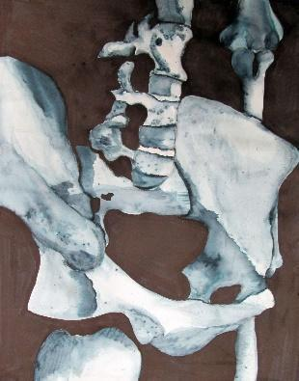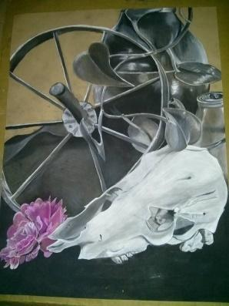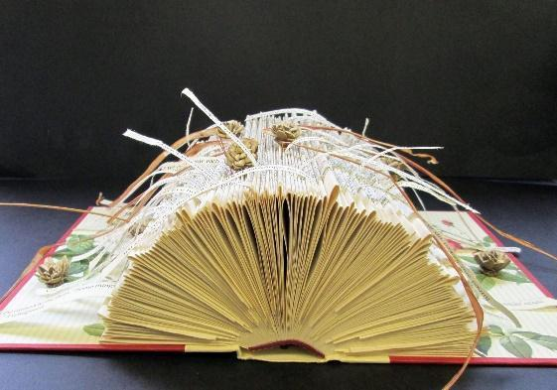

Advanced Art I
40 weeks, 1 credit
Prerequisites: Studio Art

Over the course of the year in Advanced Art I, students will continue working with a wide variety of media and techniques. The elements of art and principles of design, art history, criticism and aesthetics are integral parts of the curriculum. Drawing skills and drawing from life is still a main focus although experimentation with materials and ideas is highly encouraged and expected. At this level, students are expected to work more independently in response to project themes. Students are expected to seek out solutions to problems, to research ideas they may have, to plan out projects and execute them with self-discipline. Participation in art shows and the development of a college entry portfolio will begin in Advanced Art I. A new focus on how art can be used in your future career will be explored.
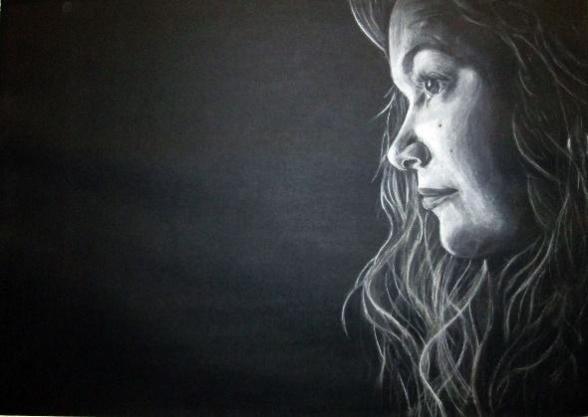
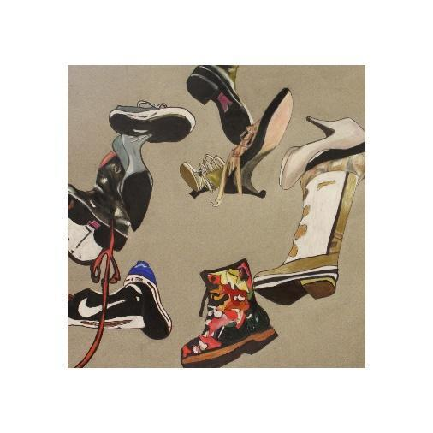
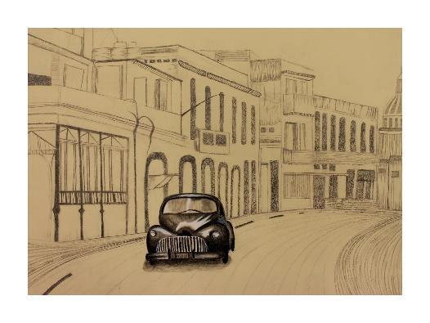
Advanced Art II
40 weeks, 1 credit
Prerequisites: Studio Art and Advanced Art I
In Advanced Art II students will continue to use and learn about a wide variety of media and techniques. Sculptural work, video, and photography will also be investigated or incorporated in pieces since today’s artists do not limit themselves to one medium and often include multiple techniques in one piece alone. Students are expected to strive to master mediums and use media to best express your own intended ideas. Experimentation with materials and ideas is expected. Individual research into different media or techniques is also expected at this level. Students will work more independently to create a personal, college entry portfolio that is focused and deliberate. Artwork should express individual ideas and skills. With each assignment, advanced students will be expected to take the assignment rules and run with it, creating pieces that are very individual and expressive.
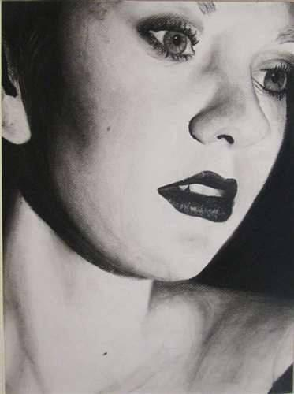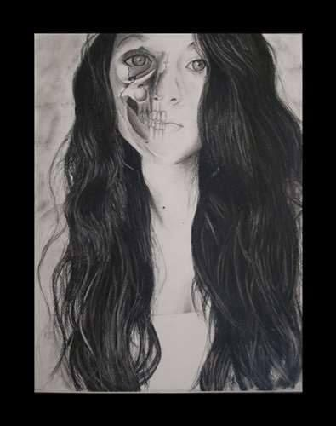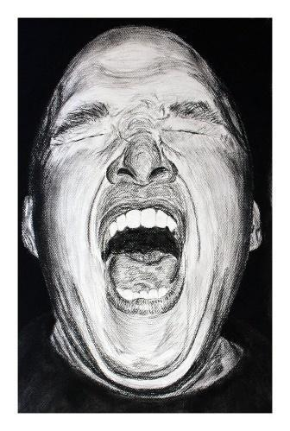

Sculpture
40 weeks, ½ Credit
Prerequisite: Studio Art

During this course, students will work with a variety of materials to creatively solve problems using 3D design. This upper-level art course offers an opportunity for students who wish to create three-dimensional art. Students will explore the element of form using a variety of materials such as clay, plaster, wood, and metals. Final products will be displayed around the school and community. Students are encouraged to explore individual styles while producing a diverse body of three-dimensional work.
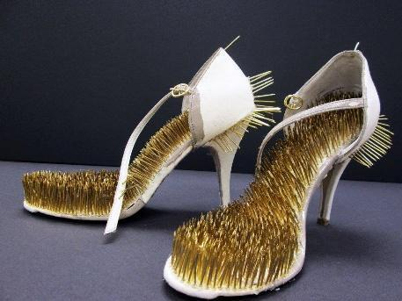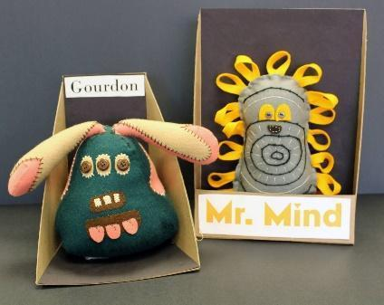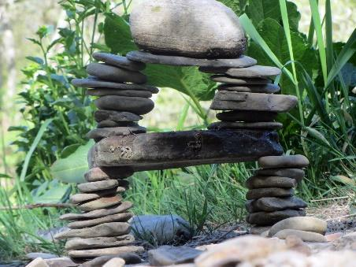

Photography
40 weeks, ½ Credit
Prerequisite: Studio Art

Photography captures moments in time and allows us to view the world through a different lens, either as the viewer or the photographer. The evolving technology of photography is exciting and inspiring. In this course, students will be exposed to the history of photography as well as contemporary photographers and methods. Students will learn the fundamentals of Photoshop and basic digital photography skills and composition. Students will explore several themes and techniques throughout the year and will complete a personal portfolio in June. Time outside of class is required for shooting images on a regular basis.

Fashion Design
40 weeks, ½ Credit
Prerequisite: Studio Art

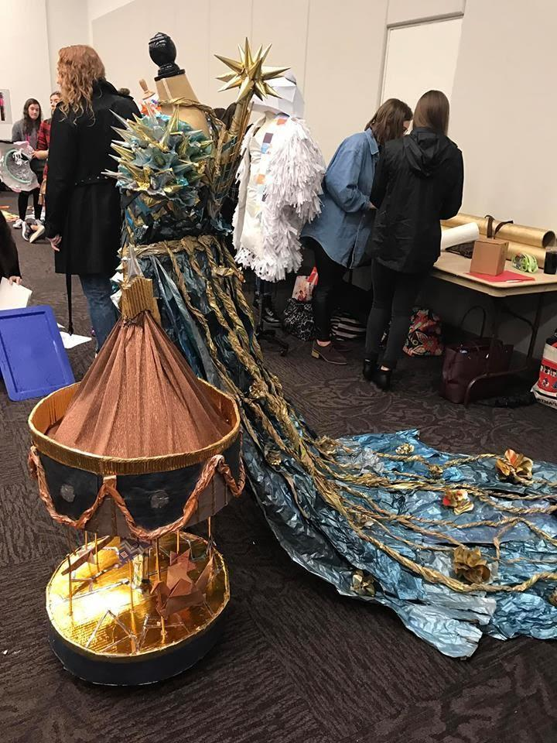
Explore the fashion industry from design through production and find your individual style in this introductory course. We will explore the history, current trends, and future of fashion. Through fashion sketching, you will create signature looks and build toward sketching your very own collection by the end of the course. Collaborate to create competitive fashion designs to be shown on the runway!
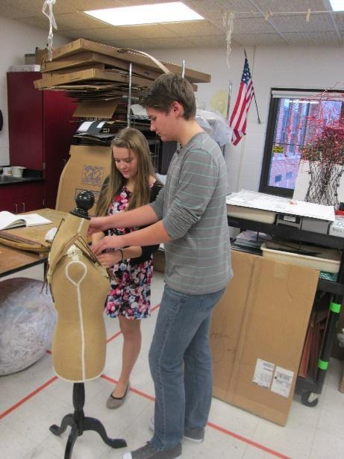
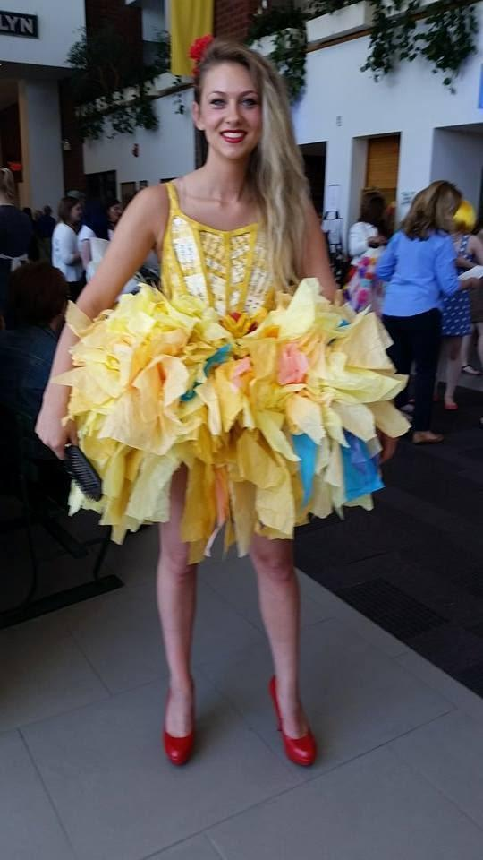

Architecture
40 weeks, ½ credit
Prerequisite: Studio Art

Introduction to architectural ideas, principles, and methods of exploring architectural problems in a studio setting. Through a graduated sequence of exercises culminating in a final project, students study architectural concepts of space, form, function, environment, and technology. Field trips investigate contemporary architecture within New York.
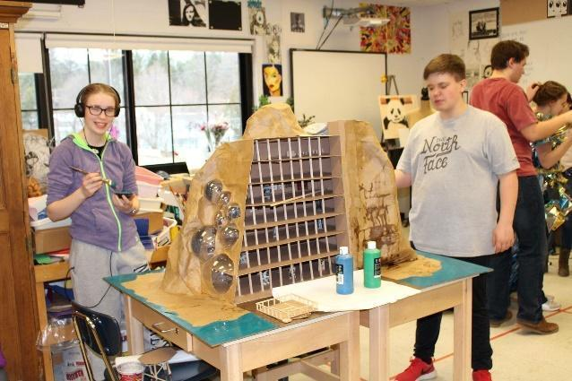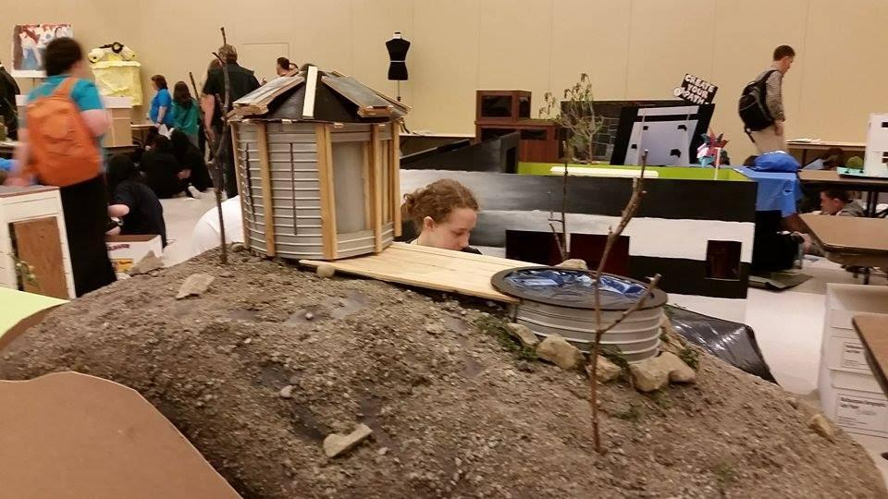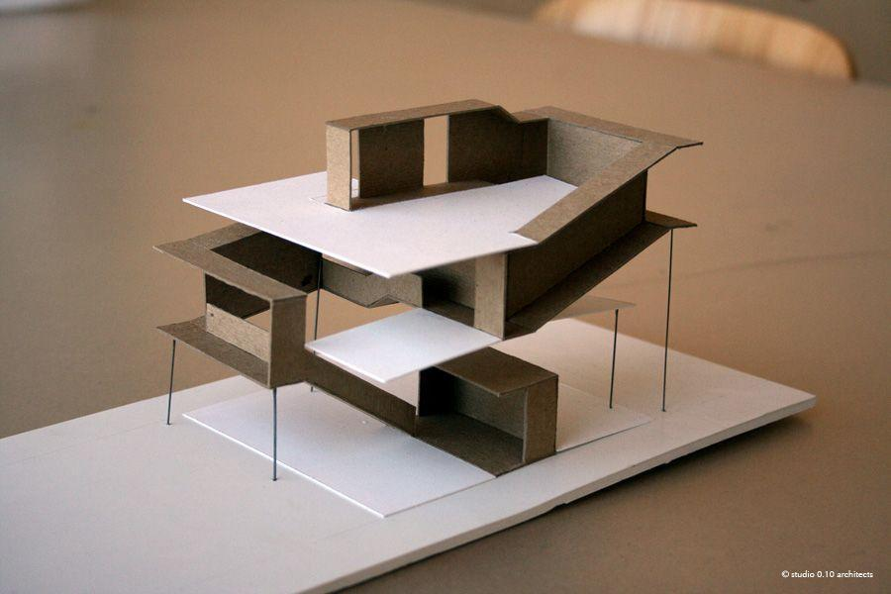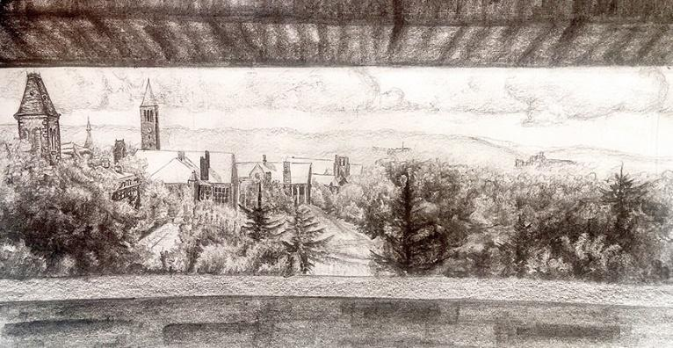

Ceramics
40 weeks, ½ Credit
Prerequisite: Studio Art
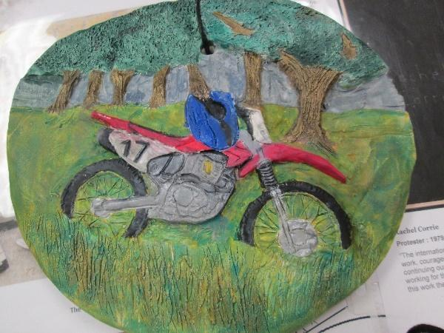
This course provides a comprehensive study in methods of sculpture, hand-built clay construction and basic wheel throwing techniques. Students explore three dimensional design while developing both useful and sculptural forms. Creativity and quality craftsmanship are emphasized.
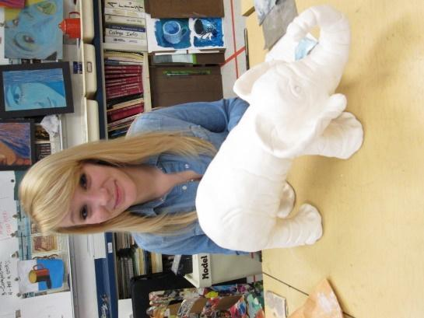
Media Arts and Design (MAD) I
40 weeks, 1 credit
Grade 10-12
Prerequisites: Studio Art
Technical media has become a powerful means of telling a story, conveying information and communicating ideas in contemporary culture. Our world is a visual one. We are constantly bombarded with imagery from television, video games, movies, video, magazines, fashion, and the list goes on. All of this imagery is created by artists. Art plays a larger role in society and the workplace than it ever has before. Students will investigate new and growing career avenues that have opened up in communications, the arts, and technological studies due to the internet and our exposure to mass media. Students will apply their knowledge of design principles to strengthen their visual literacy and communication skills. Possible projects include logo development, poster design, book arts, computer generated art, digital photography, and video work. Students will study how the computer is used as an innovative tool by both commercial and fine artists to create original artistic images. Students will become knowledgeable about how the computer functions as they create inspired, unique images using computer graphics software such as Adobe Illustrator and Adobe Photoshop.

Introduction to Photojournalism
Grade Level: 10-12
TC3 Credit Hours: 3
40 weeks ½ credit
Cincinnatus Central School

Course Description:
Photography captures moments in time and allows us to view the world through a different lens, either as the viewer or the photographer. Photojournalism is a form of journalism which tells a news story through powerful photography. Students will be exposed to the history of photography as well as contemporary photographers, photojournalists, and methods. Students will explore the full potential of the digital camera, and master a variety of techniques in Adobe Photoshop. Time outside of class is required for shooting images on a regular basis.
Course Prerequisites: Studio Art
This course is designed for Art sequence students in grades 10, 11, and 12.

MUSIC

Senior High Chorus
Grade level: 9-12
Number of weeks: 20
Prerequisite: 7th and 8th Grade Chorus or permission of instructor
Number of credits: ½

Senior High Chorus is a performing ensemble in which the students expand upon their learning from 7th and 8th Grade Chorus. This course covers four important dimensions of the choral experience: basic vocal techniques (proper breathing, support and placement), sight singing (learning to read music at sight), historical contexts (learning about the composer and historical period a given piece was written), and repertoire (learning music of various styles and periods for concerts and special events, and making critical judgments in rehearsals).

Senior High Concert Band
Grade level: 9-12
Number of weeks: 20
Prerequisites: 7th and 8th Grade Band or permission of instructor
Number of credits: ½

Senior High Concert Band is a performing ensemble. Students attend weekly rotating lessons. The ensemble will provide a comprehensive education and musical outlet for students. Through active participation in the instrumental program, students will develop an intellectual understanding of all types of music, thereby instilling an appreciative outlook toward culture, music, and the beauty it expels. Students will acquire values, pride, confidence, and a sense of personal identity. Students will develop the life skills of self-discipline, goal setting and perseverance. Music education utilizes the ability to critically evaluate works, and develop higher order cognitive skills of problem solving and creative thinking incorporated in interdisciplinary subjects. The music program will strive to meet the standards set for music on a national level. Required performances include fall, winter, and spring concerts, Music in Our Schools Month Concert, Sherburne Pageant of Bands, area festivals, and the graduation ceremony. Extracurricular opportunities include Marching Band, Jazz Band, NYSSMA Solo Festival, Music Council, and All-County Band.

COMPUTER & TECHNOLOGY

Computer Applications
Grade level: 9-12
Number of weeks: 40
Number of credits: ½

This course will concentrate on teaching the basic fundamental computer skills and knowledge essential for personal computer use and job productivity. The course begins with the focus on learning touch typing skills, using various software programs to promote proper form, speed, and accuracy. Although the focus of the class changes throughout the year to other skills and software, keyboarding skills are emphasized and practiced through the entire course. In addition, all computer assigned projects will involve using 21st Century Skills and searching for information on the Internet to give students experience navigating the vast amount of resources available on the World Wide Web.
For the remainder of the course, the Microsoft Office suite will be taught; commencing at the beginner level and then approaching the use of computer applications at the intermediate level to continue to challenge students who are already computer literate with word processing, the Internet, and email skills. Word processing in Microsoft Word is the first program taught in the suite. Then course content expands their knowledge by introducing three additional types of computer applications: spreadsheet management with Microsoft Excel, database management with Microsoft Excel and slide show presentations with Microsoft PowerPoint. Windows utility functions will also be incorporated to teach students file management and how to better organize their work.

Media Arts and Design (MAD) I
Grade level: 10-12
Number of weeks: 40
Prerequisite: Studio Art or Teacher Recommendation
Number of credits 1

Technical media has become a powerful means of telling a story, conveying information and communicating ideas in contemporary culture. Our world is a visual one. We are constantly bombarded with imagery from television, video games, movies, video, magazines, fashion, and the list goes on. All of this imagery is created by artists. Art plays a larger role in society and the workplace than it ever has before. Students will investigate new and growing career avenues that have opened up in communications, the arts, and technical studies due to the internet and our exposure to mass media. Students will apply their knowledge of design principles to strengthen their visual literacy and communication skills.
Possible projects include logo development, poster design, CD covers, book arts, computer generated art, digital photography, and video work. Students will study how the computer is used as an innovative tool by both commercial and fine artists to create original artistic images. Students will become knowledgeable about how the computer functions as they create inspired, unique images using computer graphics software such as Adobe Illustrator and Adobe Photoshop.

Media Arts and Design (MAD) II – when offered
Grade level: 10-12
Number of weeks: 40
Prerequisite: Studio Art and MAD I
Number of credits 1

In MAD II, students will use their design and computer skills acquired in MAD I to create more complex projects. Emphasis will be placed on the communication of an idea or story to the viewer using new media and inventive combinations of media. The creation of a college level portfolio will be a main focus of the course. Those interested in pursuing a career in graphic design, animation, web design, communications, movie design, or art should take this course.

Computer Publications I
Grade Level: 11 - 12
Number of weeks: 40
Number of credits: 1

Computer Publications is designed to be a project-based course for students who are ready to apply the skills they have learned thus far, not only in the computer sequence but in other subject areas as well. Students will be actively engaged in photography, digital editing, graphic design, as well as reading, writing, thinking, speaking and listening throughout the entire course. The students enrolled in this course use desktop publishing skills at a professional level designing and publishing the school district newsletter and the annual school yearbook. In addition, the students work on production of a supplementary multimedia CD and various other school related publishing projects. Students will gain experience in the world of desktop publishing and its hi-tech tools. Using state-of-the-art equipment and market-leading software packages, students will design and create their own professional quality publications. In addition to learning the precise skills of typography and layout design, students will also learn essential communication skills and effective photo-journalism techniques. Computer Publications can be taken a second year for another credit. These students are the students running the production of the projects and are responsible for helping to train and teach incoming students as well as manage the production of various projects.

Computer Publications II
Grade Level: 12
Number of weeks: 40
Prerequisite: Computer Publications I
Number of credits: 1

Computer Publications II is for students who have successfully completed Computer Publications I. Students select a specialty area they wish to master that was introduced in Computer Publications I. The students enrolled in this course will be the senior members of the computer publication team responsible for designing and publishing the school district newsletter. Once students have gained experience by rotating through job assignments every 6-weeks in Computer Publications I, it is time for students to interview for the job they would like to pursue at a more advanced level. Job titles may include photographer, video producer, chief editor, layout editor, online manager, and other positions. At the same time, students are responsible for feature articles in every issue of The Lion's Roar.
Video production will be introduced in this course and will open up new assignments such as video interviewing and video capturing.
Like Computer Publications I, this course is designed to simulate an authentic office environment where students are challenged to develop targeted skills. It will allow them hands-on activities, which provides young learners to master certain competencies related to newspaper production, researching and reporting along with some entrepreneurial knowledge. This course gives students the opportunity to experience similarities to a career in journalism and reporting. It also exposes students to work like responsibilities and forces them to better manage their time to meet production deadlines and assignments outside of class to cover news stories
Students will be asked to train new hires (members of the Computer Publications I class). Members of this course will also be responsible for posting various sections for the Lion’s Roar online at http://www.cc.cnyric.org

E-Sports
Grade Level: 9-12
Number of weeks: 40
Prerequisite:
Number of credits: ½

Esports is short for electronic sports, it’s a form of competition using video gaming. Here at Cincinnatus we have a newly renovated Esports room. The room was custom built for gaming with LEDs on the walls and twin curtains to block the sun from glaring on the screens.We currently have 10 Asus gaming pc’s set up. We have 5 more Lenovo t7 Gaming Pc’s on the way. We have Nintendo switches and two large tv’s with 4 gamer egg style chairs. We also have on order for next year some Microsoft Xbox’s. I am also trying to build a vintage gaming system area also.

We are part of the High school Esports league (HSEL). We have 10 games to choose from for game play. Currently we play Chess, Fortnite, Brawlhalla, Rocket league, and Valorant. During our class time we practice for our competition solo and or as a team. HSEL has two seasons, the fall and spring major. All of our competition games are played after school with more than one queue time to choose from. As a gamer you can stay after school and play during our club time 3:30 to 6:00 or you can play from home. We are in the eastern division and play other schools from Maine to Virginia. Students can win prizes and scholarships for college. A lot of colleges are starting Esports teams and some schools are offering an Esports degree.

Drones/Robotics
Grade Level: 9-12
Number of weeks: 40
Prerequisite:
Number of credits: 1

In Drone class students learn how to fly multiple drones both indoors and outdoors. Students will study the Federal Aviation Administration rules. Students will take The Trust Test and receive a recreational drone pilot's license that is valid for life. Students start flying with tiny whoop drones that fit in the palm of your hand in the classroom. Once they have some hours of practice we start flying outside with trainer drones (syma x5). With these drones the students have to learn how to adjust to the wind and changing conditions. Once students are proficient at flying we move on to professional drones.

Our professional drones are:

DJI FPV
DJI Tello
DJI Mini 3 Pro
Autel Evo 2 Pro
Autel Nano

New for next year is:

Drone Blocks where we use coding languages to make DJI Tello drones fly and complete missions.

Drone soccer uses a 20x10 enclosure along with hand built drones inside a protective bubble to play soccer. Each team has a goal and the drones are in full contact with each other. The only way to score is to get the drone through the hoop. We will practice in class where we will modify our drones to compete against other schools in our area.

AGRICULTURE
Plant Science:
Grade level: 9-12
Number of weeks: 40
Prerequisite:
Number of credits 1

Do you like to plant? Want to know how things grow? Interested in growing your own garden? Want to learn how to manage fruit trees or an orchard? You can learn all this and more in Botany! This course will explore the many career options available in the Plant Science industry. Learn how plants grow, how to propagate more of them, manage a greenhouse plan, create a planting plan, grow seedlings to sell, manage fruit trees, grow indoor plants, and much more. Mostly project based class where you will be planting, propagating, planning a plant sale, and learning about the industry and careers it has to offer.

Animal Science:
Grade level: 9-12
Number of weeks: 40
Prerequisite:
Number of credits 1
Horses, pigs, and cats, oh my! This class is designed to introduce students to animals used in agricultural production along with a few companion animals. Students will learn what part each animal plays in today’s society, their anatomy, breeds of each animal, feeding guidelines, reproduction, management, and basic disease diagnosis. The class will look at animals for production such as cows, sheep, pigs, etc., small animals, and animals for recreation. Other topics taught in this course include animal anatomy and physiology, animal diseases, and animal research. Animal Science students will learn about a variety of careers such as animal behavior, veterinary sciences, agriculture, biotechnology, and many more. Want to be able to work with animals during school hours? Take trips to visit local producers? Listen from industry professionals in class? Network with possible employers? This is the class for you! Mostly project based class where you will be getting your hands dirty and doing.
Food Science
Grade level: 10-12
Number of weeks: 20
Prerequisite: Animal Science
Number of credits 1/2

Do you eat? Then there is something you can learn from this class! We will be making our own food, exploring marketing of food, food composition and nutrition, food additives and regulations, food safety and toxicology, food processing, food engineering, food biotechnology, product development, and sensory evaluation. This industry is vast and includes many facets. Trips to food processors, guest speakers, and eating are all important parts of this class. Maybe you will find your future career in class! This is primarily a project-based class where you will be getting your hands on experience preparing and marketing food.

Agricultural Business
Grade level: 10-12
Number of weeks: 20
Prerequisite: Animal Science
Number of credits 1/2

A business class with an agricultural twist! Think you want to go into the business world but not really the agriculture side of it? Guess what! The basic principals are the same. Students will understand basic economic and business principles used in the agriculture industry, from production to retail. Explore macro and micro economics, marketing and design a business plan! Get the opportunity to meet with business leaders in our local agricultural community.

Veterinary Science
Grade level: 10-12
Number of weeks: 40
Prerequisite: Animal Science
Number of credits 1

Think you want to be a vet? Want to be able to understand what your veterinarian is talking about in regards to your pet or livestock? Want to be able to do simple procedures on your own? This is the class for you! Major topics include veterinary terminology, safety, sanitation, anatomy/physiology, clinical exams, hospital procedures, parasitology, laboratory techniques, nutrition, disease, office management, and animal management. Veterinary schooling/careers and related careers are also explored. Dissections are a part of this class. Trips to veterinary college, vet clinics, guest speakers and more. Mostly project based class where you will learn and utilize skills used in the Veterinary industry.

Pathways

Animal Science Pathway
Animal Sci
Vet Sci
Food Sci or Ag Business
Dairy Management (possible future class)

Plant Science Pathway
Botany
Design and Agriculture
Food Sci or Ag Business

Food Science Pathway
Botany
Ag Business or Animal Sci
Food Sci

Ag Business Pathway
Botany or Animal Sci
Ag Financial Mgmt and Marketing (possible future class)
Ag Business
HEALTH AND PHYSICAL EDUCATION

High School Health Education (Concurrent Enrollment)
Grade level: 11 & 12
Number of weeks: 20
Prerequisite: None
Number of credits: ½ HS - 3 college credits from TC3

Health Education covers the factual information concerning topics of mental health, family living, consumer health, nutrition, first aid and safety, physical fitness, drug education, disease prevention, personal health, community health, and growth development. Emphasis will be provided in health promotion and risk education to help students prevent and manage health issues in their lives. This class provides students with an understanding of modern health concepts and how these concepts are related to their present and future needs. A ½ credit of health is required for graduation.

High School Physical Education
Grade level: 9-12
Number of weeks: 20
Prerequisite: None
Number of credits: ½

A wide variety of lifetime, team, and individual sports will be offered to each grade level. Included in the physical education program is an emphasis on total fitness, self-awareness, sports knowledge, proper health practices, and the general enjoyment of sport and physical activity. Physical Education units include, but are not limited to, aerobics, archery, badminton, basketball, bowling, dance, field hockey, fitness testing, flag football, floor hockey, golf, indoor soccer, racquetball, self-defense, soccer, volleyball, and weight training. Students must earn ½ credit of PE each year they are enrolled in high school to meet NYS graduation requirements. Student Athletes are required to be enrolled in Physical Education each semester while competing in league athletics.

BOCES CAREERS AND TECHNICAL EDUCATION COURSE OFFERINGS AT MCEVOY CAMPUS

Juniors and Seniors have the opportunity to attend BOCES Career and Technical Education courses in the following areas:
• Automotive Collision Technology
• Automotive Technology (National Automotive Technicians Education Foundation)
• Computer Technology
• Construction Technology
• Cosmetology
• Culinary Arts
• Early Childhood
• Graphic Communication
• Health Occupations Technology
• Heavy Equipment Repair, Operation, and Diesel Technology
• Physical Therapy
• Welding Technology

Automotive Collision Technology
Two years/3 credits per year
(Science junior year, Math senior year)*
This program prepares students for occupations in the auto body collision repair industry or for technical college. Students learn the basic skills and techniques using the most current business/industry-based technologies. Students progress into frame straightening, custom colors in painting, and estimating. Repairs covered in this two-year program include: auto body materials, color matching, custom painting, paint products, hand and power tools, basic measurement skills, high-strength steels, and plastic and composite part repair. Greater emphasis on ASE certification and I-Car standards in the auto collision technology class involves students in a hands-on training program for a career in the Auto Collision profession. Three credits earned per year.

Automotive Technology NATEF
Two years/3 credits per year
(Math junior year, Science senior year)*
The auto technology program is designed to provide students with basic mechanical knowledge and skills. Students gain knowledge and skills through a combination of lecture and lab work, including hands-on repair of vehicles. All repair work is performed by the students. The jobs range from a simple oil change to complex on-board computer system repair. This program, which is state and nationally certified, is the first step in preparing for a career in the technical repair field. It prepares the student for entry-level employment as a service maintenance person or for advanced technical education. Automotive students will be responsible for NATEF classroom theory, and NATEF-applied Communications, Mathematics, and Science. Students will have the opportunity to complete more than 200 NATEF shop labs within the four areas. Some labs may be performed at local repair facilities. Students will be given the opportunity to become certified as a general service technician.

Computer Technology Program
Two years/3 credits per year
(Science junior year, Math senior year)*
This program offers certification through CISCO. The first year of the program deals with repair and rebuilding of computers. The IT Essentials course is divided into two sections; the first covers core competencies in the latest hardware and software technologies with emphasis on information security skills, safety and environmental issues, and 21st century skills. The second year prepares a student to be a network support specialist. Internships in the second year will expose students to the business aspect of computer technology. This fast-paced program will make any student a capable computer technician for any business/career path. Three credits earned per year. Students may elect to receive three college credits from TC3 for each year of the program (total of six credits) by successfully completing the TC3 concurrent enrollment requirements.

Construction Technology
Two years/3 credits per year
(Math junior year, Science senior year)*
The Construction Technology program emphasizes the development of skills in rough carpentry, masonry and concrete work, residential electricity, plumbing and heating, finish carpentry, cabinet making, and roofing and siding. Areas of study will include: OSHA- and NOCTI approved construction safety standards, residential construction, framing, roofing, siding, drywall finishing, blueprint reading and drafting, cabinet installation, residential wiring, basic electrics, Energy Star-approved insulating standards, site layout, and trim carpentry. Valuable experience is gained in all phases of residential construction. In addition, students have the opportunity to specialize in the construction trade area of their choice. Three credits earned per year.

Cosmetology – Appearance Enhancement Profession
Two years/3 credits per year
(Science junior year, Math senior year)*
The Cosmetology program provides training in hair, skin, and nail analysis. Product knowledge, technical application, and procedures are taught in the areas of shampooing, massage, styling, shaping, coloring, and hair reconstructing. Elective areas include esthetics and nail technology. Curriculum is designed to provide 1,000 hours of interactive instruction and allows practice and theory in individual and group settings. Those students who have completed 1,000 hours of training are eligible to take the written and practical examination to obtain a New York State license. Three credits earned per year.

Culinary Arts
Two years/3 credits per year
(Math junior year, Science senior year)
First year students will concentrate on food service careers, sanitation, food safety, tools, and equipment. Applied math, basic art of baking, cold and hot food preparation stations, and cooking methods are covered. Second year students will complete modules not completed the first year and explore careers in related areas including: restaurant management, institutional facility management, franchise management, grocery suppliers, public health, and facility layout and design. Certification in sanitation and beef is also offered. Project-based portfolios will round out the second year. Both written and verbal communication skills are emphasized. Three credits earned per year.

Graphic Communication
Two years/3 credits per year
(Science junior year, Math senior year)
Graphic Communication encompasses many areas of study in Graphic/Computer Design. The design portion is centered on computer-generated projects. Adobe Photoshop Macromedia, iMovie, PageMaker, and FreeHand software offer students different ways to digitally design and illustrate real and simulated projects. These projects may include: publications, book covers, logos, flyers, posters, Web page advertisements, and other commercial applications. There is also a photography component to this course. Three credits earned per year.

Health Occupations Technology
Two years/3 credits per year
(Math junior year, Science senior year)
This course is offered to students who would like to explore options working with the elderly in the health care setting. Students will also have the chance to explore careers within the health care field. Some of these careers include: nursing, nutrition, and physical and speech therapy. The second year focuses on medical terminology through a systems-based approach. The second year also offers the student a chance to receive three credits from TC3 for a Medical Terminology class. At the end of the second year, students who have accrued enough clinical hours will take the New York State Certified Nursing Assistant certification test. This test is not required in order to pass the course but is an opportunity to be job ready upon graduation. This class offers excellent preparation for students planning to pursue a career in allied health. Three credits earned per year.

Heavy Equipment Repair, Operation, & Diesel Technology
Two years/3 credits per year
(Math junior year, Science senior year)
Located at All-County Collision & Repair in Homer, the two-year Heavy Equipment Repair, Operations and Diesel Technology program is designed to offer students essential skills in the operation and repair of heavy equipment and heavy-duty diesel trucks using the latest techniques and diagnostic equipment. Students will gain daily practical experience working with a variety of engines and equipment that will prepare them for employment opportunities or furthering their education at college and technical schools. Students may be eligible to earn industry certifications in safety training and equipment operation. A Career and Technical Endorsement on their high school diploma will signify that students have met the rigorous industry standard upon successfully passing a technical assessment., .

Physical Therapy
Two years/3 credits per year
(English 12 junior year, Science senior year)
The employment outlook for skilled physical therapists and physical therapist assistants is expected to increase 43 percent from 2010 to 2020. The demand for physical therapy services is predicted to increase in response to the health care needs of an aging population. This half-day, two-year program will give students knowledge and technical skills that will prepare them for post-secondary education in a physical therapist and physical therapist assistant college program. Work-based learning sites provide students with the opportunity for Internships and shadowing at local physical therapy clinics.

Welding Technology
Two years/3 credits per year
(Math junior year, Science senior year)
Students in this two-year program learn metal-working processes that include: welding, cutting, grinding, and custom fabrication. Students learn by using steel, aluminum, and other metals commonly found in modern industry. Daily hands-on training exercises reinforce skills that enable students to reach entry-level proficiency in stick welding, MIG and TIG welding, flamecutting, plasma cutting, tool, and equipment use. Shop math, blueprint reading, group learning, and career exploration complement the manual skills learned in the workshop. Safety practices and craftsmanship are priorities, and student projects are strongly encouraged. Second-year students can enter the welding industry with the help of paid and unpaid internships. Graduating students are qualified and prepared to perform entry-level work in the field or to attend post-secondary educational institutions. Three credits earned per year.

*Students enrolled in these courses are also required to take Data Analysis (Math) and
Scientific Inquiry (Science) provided at BOCES for one credit per year. Please refer to the
OCM BOCES Credit Recommendations Sheet for further information or contact the
Career and Tech Ed Office at (607) 758-5262.

Data Analysis and Statistics/Business Math Course
1 credit
Data Analysis and Statistics/Business Math program emphasizes content and the development of skills in mathematics as they apply to the workforce area that the student has selected. Students will learn enhanced problem solving, review skills, and gain valuable experience in related technical applications of mathematical skills. Students may elect to receive college credit from TC3 in Business Math by successfully completing the TC3 final exam. Data Analysis and Statistics/Business Math course is a requirement for all students.

Scientific Inquiry and Research
1 credit
Scientific Inquiry and Research stresses content and skills development in science as they apply to the workforce area that the student has selected. Students will use various applications of scientific methods and skills, and gain valuable experience in related technical applications of science. This course is a requirement for all students.

New Vision Health Careers
One year – seniors only
Application and interview required
New Vision Environmental Science Careers is a total immersion experience in the field of Health Care. Students explore a variety of career opportunities within the hospital and at some health facilities in the community. Students will spend three hours every school day during their senior year at Cortland Regional Medical Center, which is the main sponsor. Other medical professionals in the community also offer rotation sites for interested students. The program offers four credits toward high school graduation, which may include Anatomy and Physiology, English 12, Government/Economics, and Health Careers. These subjects are integrated together under the common theme of Health Care. Students also take college English 101 through TC3 during the first semester and receive four college credits for successful completion. The program evaluation process consists of daily journal entries, essays, technical writing, textbook questions, oral presentations, group projects, quizzes (both oral and written), tests (both oral and written), and rotation packets. All assignments are interdisciplinary so that students can integrate different subject area skills together. Some of the fields that a New Vision student can explore include: physical therapy, occupational therapy, emergency medicine, cardiology, radiology, nuclear medicine, MRI, recreational therapy, respiratory therapy, nursing (Maternity, ICU, Pediatrics, Geriatrics, and General), clinical laboratory, nutrition, pharmacology, and biomedical engineering.

New Vision Environmental Careers
One year – seniors only
Application and Interview required
New Vision Environmental Science Careers is a total immersion experience in the field of Environmental Science. An emphasis is placed on “learning on your feet instead of your seat.” Students will spend three hours every school day during their senior year at Tunison Laboratory of Aquatic Science. The United States Geological Survey at 3057 Gracie Road in Cortlandville sponsors the class. Lime Hollow Center for Environment and Culture is also partnered with the program, working hand-in-hand with the students on projects throughout the year. The program consists of instruction modules that explore specific areas of Environmental Science. Units include: forestry, fish and wildlife, environmental issues, soil and water, land use, and outdoor recreation. Class time is divided between indoor instruction and outdoor application with the majority of instruction done in the 220 acres of forest surrounding the class location. Other activities offered include: overnight primitive camping, backpacking, canoeing, cross-country skiing, snowshoeing, and fishing, and outdoor adventure. Paul Smith’s College of the Adirondacks and Finger Lakes Community College award three college credits to students who enroll in their school and successfully complete this program. The curriculum allows for up to four credits toward graduation, which include: Economics, English, Environmental Science, and Government. Evaluation is portfolio-based on each of the six required modules. The student’s knowledge and skill is measured using authentic assessment. A daily journal, book reports, essays, poems, interviews, and a research project are part of the student portfolio, with a portfolio developed for each module. Research findings are presented to a panel of educators in a formal symposium style. A panel of educators and related professionals formally assesses the student\ presentation. The course is designed to introduce students to career-oriented opportunities, develop investigative skills, and provide the opportunity to interact with professionals in different career areas.

GED
High School Equivalency Diploma Program
Half Day – AM
Parent/student interview required
This course will offer a unique, independent study in preparation for the GED test. Students will study math, social studies, science, reading, and writing (grammar and composition). The student will take the test depending on his or her own initiative and determination.

